Supplement 1 – thoron decay correction
For air sampling through tubes from an exhalation container, ²²⁰Rn concentration at the instrument’s inlet, C₁ (Bq m⁻³) can be expressed as (Durridge Company Inc 2023):
 | $$C_{1}= C_{0}e^{-λ_{tn}*V_{1}/q}$$ | (S.1)
where C₀ (Bq m⁻³) is the concentration at sampling point (exhalation container), λ_{tn} is the decay constant for ²²⁰Rn (λ_{tn} = (12.42 ± 0.07) * 10⁻³ per second = (0.7452 ± 0.0042) per minute (Laraweb 2024)), V₁ (L) is the tube volume and q (L/min) is the flow rate.
A tube with length 1.75 m and diameter of 3.5 mm has a volume of 0.017 L, and the ratio C₀/C₁ is,
 | $$\frac{C_{0}}{C_{1}}= e^{0.745*0.017/0,75}=1.017$$ | (S.2)
For EQF we use recommended airflow of 0.75 L/min, but with calibration for 0.4 L/min, we correct for the equilibrium ²²⁰Rn concentration in the measurement chamber, as air fills the measurement chamber faster than the instrument was calibrated for. Thus, we solve the balance equation for ²²⁰Rn at equilibrium in the measurement chamber. Change of ²²⁰Rn particles N over time in the chamber of volume V₂ (m³) is:
 | $$\frac{dN}{dt}= C_{1}q-C_{2}q-λN_{2}=0$$ | (S.3)
where C₂ (Bq m⁻³) is the equilibrium ²²⁰Rn concentration inside the measurement chamber at its outlet valve. The last term is the decay of ²²⁰Rn in the chamber, where N₂ = C₂ * V₂. Solving this for C₂ gives us:
 | $$C_{2}= \frac{C_{1}}{1+\frac{λ_{tn} V_{2}}{q} }$$ | (S.4)
We use this to calculate the concentration in the chamber, C_{2,} from C_{1,cal} and q_{cal}, and correct for the airflow rate, achieving a corrected ²²⁰Rn concentration at inlet valve C_{1,meas} using q_{meas} = 0.75 L/min. According to the EQF 3220 manual, the internal instrument air loop volume is 250 mL. We assume this mainly comprise the chamber volume and set V₂ = 0.25 L. The correction factor for using different flow speed is:
 | $$\frac{C_{1,meas}}{C_{1,cal}}= \frac{1+\frac{λ_{tn} V_{2}}{q_{meas}}}{1+\frac{λ_{tn}V_{2}}{q_{cal}} }=0.852$$ | (S.5)
Multiplying the two correction factors gives the final correction factor for ²²⁰Rn results using the external tube and 0.75 L/min flow rate, which equals 86.7 % of the recorded value.

Supplement 2 - Measurement Time
To ensure a low detection level, the reference measurement period for ²²⁰Rn was 30 minutes the first field day and 15 minutes for the rest. Generally, for exhalation series measurements, sampling time was reduced to attain sufficient measurements during the linear phase. Measurement periods of 5, 2 and 1 minutes were tested to find the optimal counting statistics. For some 5-minute intervals, the linear phase had only two points and it was unclear whether both were actually part of the linear phase or the last was deviation so that exhalation rate was underestimated. Because of the high exhalation rate of ²²⁰Rn at the Mining Hill, even the 1-minute interval gave sufficient counting statistics (e.g Figure 1a main text). For ²²⁰Rn, all six methods for different accumulation phases to calculate exhalation rate can at this Fen locality be completed within an hour and offers a method to assess diurnal variation (but this does not hold for ²²²Rn). The fastest method is the linear phase methods, and this can give more rapid estimates of the diurnal variation. However, for methods including the threshold phase, ²²⁰Rn concentration fluctuations during threshold in some measurement series occurs and can be due to container leakage, wind effects, and variable solar heating of the exhalation container.

Supplement 3 – DEDUCTIONS FOR THE SIX METHODS
Method 1 – the old way, simulating sealed-cans
We use datapoints from the whole accumulation process to calculate the exhalation rate, Φ (Bq m⁻² s⁻¹), using the following equation.
 | $$Φ= \frac{E∙V∙λ}{S∙T_{eff}}$$ | (S.6)
Where E (Bq m⁻³ s) is the ²²⁰Rn exposure, $T_{eff}=T+ \frac{1}{λ}\left(e^{-λT}-1\right)$ (s) and T (s) is the duration of the measurement.
The uncertainty of the exhalation rate for method 1 (sealed can) is:
 | $$\frac{u\left(Φ\right)}{Φ}=\sqrt{{\left(\frac{u\left(E\right)}{E}\right)}^{2}+{\left(\frac{u\left(V\right)}{V}\right)}^{2}+{\left(\frac{u\left(λ\right)}{λ}\right)}^{2}+{\left(\frac{u\left(S\right)}{S}\right)}^{2}+{\left(\frac{u\left(T_{eff}\right)}{T_{eff}}\right)}^{2}}$$ | (S.7)

different phases of accumulation
Change over time in activity concentration of ²²⁰Rn or ²²²Rn, C, in the exhalation container due to accumulation, can be described from the equation below. The first term is exhalation from the surface into the container. Due to surface irregularities, effective surface area is: S = 0.257 ± 0.013 m². The second term is decay in the container where λ_{i} (s⁻¹) is the is the decay constant of the radon isotope under investigation. The last two terms are leakage and back diffusion, where λ_{L} (s⁻¹) is the time constant of leakage and λ_{B} (s⁻¹) is the time constant of back diffusion.
 | $$\frac{dC}{dt}= \frac{Φ∙S}{V}-λ_{i}∙C-λ_{L}∙C- λ_{B}∙C$$ | (S.8)
Solving the equation shows the activity concentration of ²²⁰Rn can be described from the change in activity concentration over time (below), as known from ISO 11665-7:
 | $$C\left(t\right)= \frac{Φ∙S}{V∙λ}\left(1-e^{-λt}\right)$$ | (S.9)
Where $λ=λ_{i}+λ_{L}+λ_{B}$.

thus follows Method 3-5 – Linear methods
Assuming the initial linear slope of the curve is independent of back diffusion, negligible leakage, and constant exhalation rate, the linear increase of activity concentration during accumulation is (simplified):
 | $$C\left(t\right)= \frac{Φ∙S}{V}∙t$$ | (S.13)
The exhalation rate can then be expressed as:
 | $$Φ=A ∙\frac{V}{S}$$ | (S.14)
where A (Bq m⁻³ s⁻¹) is the slope of the activity concentration as a function of time, which can be calculated using linear regression. The uncertainty of the exhalation rate calculated for the initial linear phase is:
 | $$\frac{u\left(Φ\right)}{Φ}=\sqrt{{\left(\frac{u\left(A\right)}{A}\right)}^{2}+{\left(\frac{u\left(V\right)}{V}\right)}^{2}+{\left(\frac{u\left(S\right)}{S}\right)}^{2}}$$ | (S.15)

Method 2 – threshold phase
Generally, when threshold is reached, the Rn concentration (Bq m⁻³) will be:
 | $$C_{lim}=C\left(t→∞\right)= \frac{Φ∙S}{V∙λ}$$ | (S.10)
Hence, we can calculate the exhalation from the formula:
 | $$Φ= \frac{C_{lim}∙V∙λ}{S}$$ | (S.11)
Uncertainty of the exhalation rate for this method is:
 | $$\frac{u\left(Φ\right)}{Φ}=\sqrt{{\left(\frac{u\left(C_{lim}\right)}{C_{lim}}\right)}^{2}+{\left(\frac{u\left(V\right)}{V}\right)}^{2}+{\left(\frac{u\left(λ\right)}{λ}\right)}^{2}+{\left(\frac{u\left(S\right)}{S}\right)}^{2}}$$ | (S.12)

Method 6 – exponential fitting – using all phases of accumulation
The linear increase and the threshold phases are both included, using non-linear least squares exponential fitting (R Core Team 2016), and the model of Seo et al (2018).
 | $$C\left(t\right)= B\left(1-e^{-kt}\right)$$ | (S.16)
In addition, we include the reference measurement. Where $B= \frac{Φ∙S}{V∙λ}$ (Bq m⁻³) and $k=λ=λ_{i}+λ_{B}+λ_{L}$ (s⁻¹). Parameters B and k are used to estimate exhalation rate.
 | $$Φ= \frac{B∙k∙V}{S}$$ | (S.17)
The uncertainty of the exhalation rate is:
 | $$\frac{u\left(Φ\right)}{Φ}=\sqrt{{\left(\frac{u\left(B\right)}{B}\right)}^{2}+{\left(\frac{u\left(k\right)}{k}\right)}^{2}+{\left(\frac{u\left(V\right)}{V}\right)}^{2}+{\left(\frac{u\left(S\right)}{S}\right)}^{2}}$$ | (S.18)

Supplement 3.6 – 222Rn grab sampling
Mixed atmospheres of ²²²Rn and ²²⁰Rn involve bias on measurements from ²²⁰Rn progeny affecting regions of interest (ROI) in alpha spectrometry where ²²²Rn progeny are counted (Turtiainen et al. 2022, Sarad AN-004). Since progeny of ²²⁰Rn are short-lived, a grabbing procedure allowing its decay before measuring ²²²Rn, would give much lower detection limit and less uncertainty in measurements.
The half-life of ²²⁰Rn daughter ²¹⁶Po is 0.148 s and secular equilibrium is instantaneous. Some alpha particles from ²¹⁶Po lose energy when hitting detector walls and may be counted in the lower alpha energy region of interest (ROI) for ²²²Rn progeny ²¹⁸Po. In Fen, where the ²³²Th series dominates, ²²⁰Rn thus poses a real problem for ²²²Rn measurements. We solved this by grab sampling into a closed tube system and letting ²²⁰Rn and ²¹⁶Po decay before measuring ²²²Rn. First, we run air through the tubes for 5 minutes to fill it with the air to be sampled. To grab, we make a closed tube-loop between the instrument in-valve and the out-valve and wait for decay within the loop. Enough ²²⁰Rn needs to decay so that the tailing from ²¹⁶Po does not affect the signal in the ROI for ²¹⁸Po. In the redrock part of Fen complex, ²²⁰Rn has levels as high as 300 000 Bq/m³ in the exhalation container and therefore each waiting period after the grab-sample must last for at least 15 minutes (more than 15 half-lives). Simultaneously during the wait, since the half-life of ²¹⁸Po is 3.071 minutes, ²¹⁸Po comes to secular equilibrium with ²²²Rn during five half-lives. Then, ²²²Rn is measured for 30 minutes. If the anticipated ²²²Rn concentration was low (as with reference measurements), we used longer measurement times to attain a sufficient MDA.

Supplement 4 – soil gas measurements
A hardened Steel Soil Gas Probe from Durridge was pushed 25-35 cm into the soil and connected to the instrument via a vacuum gauge with water shutoff valve and 3-meter tubing. Soil gas was extracted from the ground using the instruments pump. The combined volume of the steel probe, water shutoff valve and tube volume combined are 0,115 litres. For corrections due to decay of ²²⁰Rn, please see Supplement 1 (Equation S.1 for RTM1688 since it is calibrated at the same flowrate and Equation S.1 and S.5 for EQF due to the flow rate of 0,75 l/min). On one day the EQF was the only instrument and on three days the RTM was the only applied instrument for ²²⁰Rn soil gas. On five field days, both EQF and RTM were used for soil gas measurements. This revealed a bias in ²²⁰Rn between the instruments where EQF254 had a mean of 6,300,000 Bq m⁻³ (SD: 1,400,000) while the RTM119 had mean of 4,400,000 Bq m⁻³ (SD: 1,000,000). The EQF was always used first and the RTM afterwards, which may have affected the bias. To account for the bias, and since EQF was used for all exhalation measurements, we used the mean of the bias to estimate what would have been EQF values on the three days when only RTM was used.

Supplement 5 – residual and QQ plots of statistical models
Mod 1 AIC=382 R2adj=0.64 F-stat: 24.39 on 3 and 37 DF, p-value: 6.999e-09

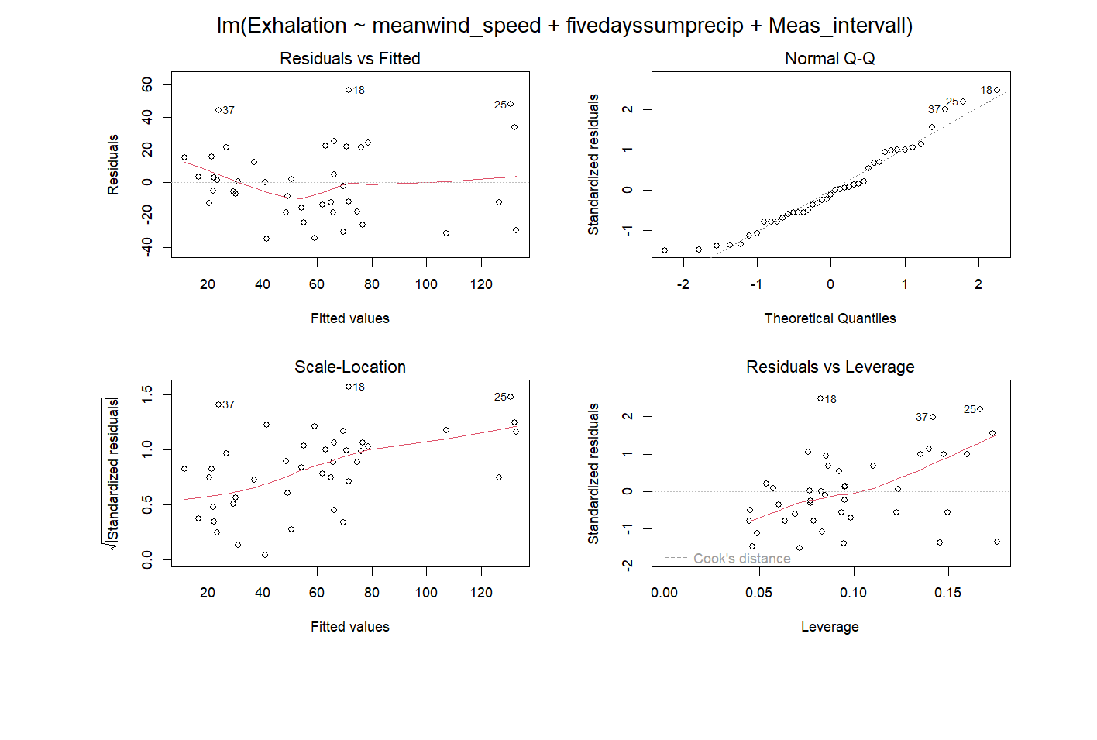

Mod2 AIC=397 R2adj=0.70 F-stat: 24.56 on 4 and 36 DF, p-value: 7.289e-10

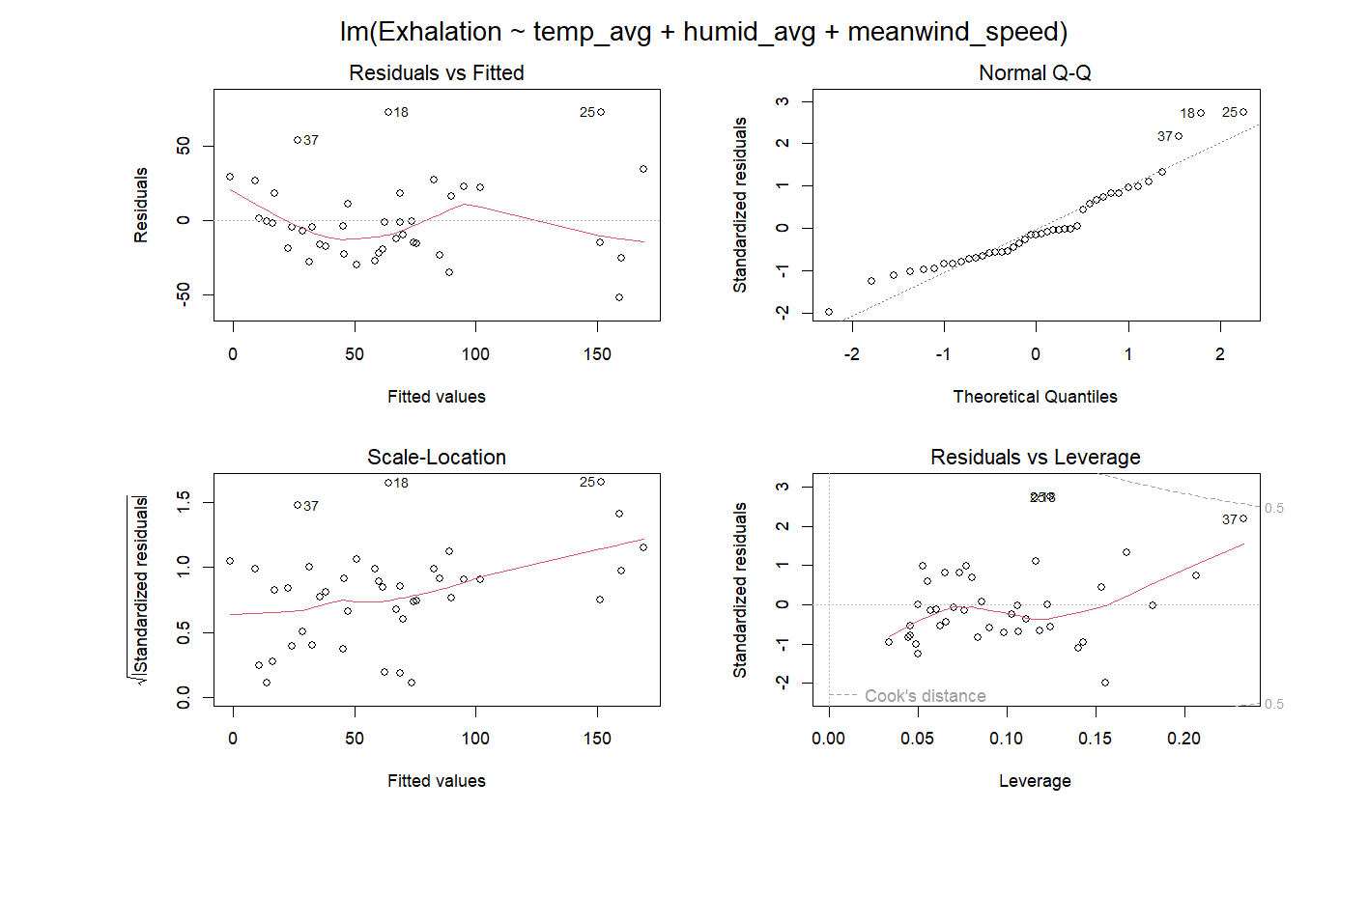

Mod3 AIC=398 R2adj=0.64 F-stat: 36.57 on 2 and 38 DF, p-value: 1.395e-09

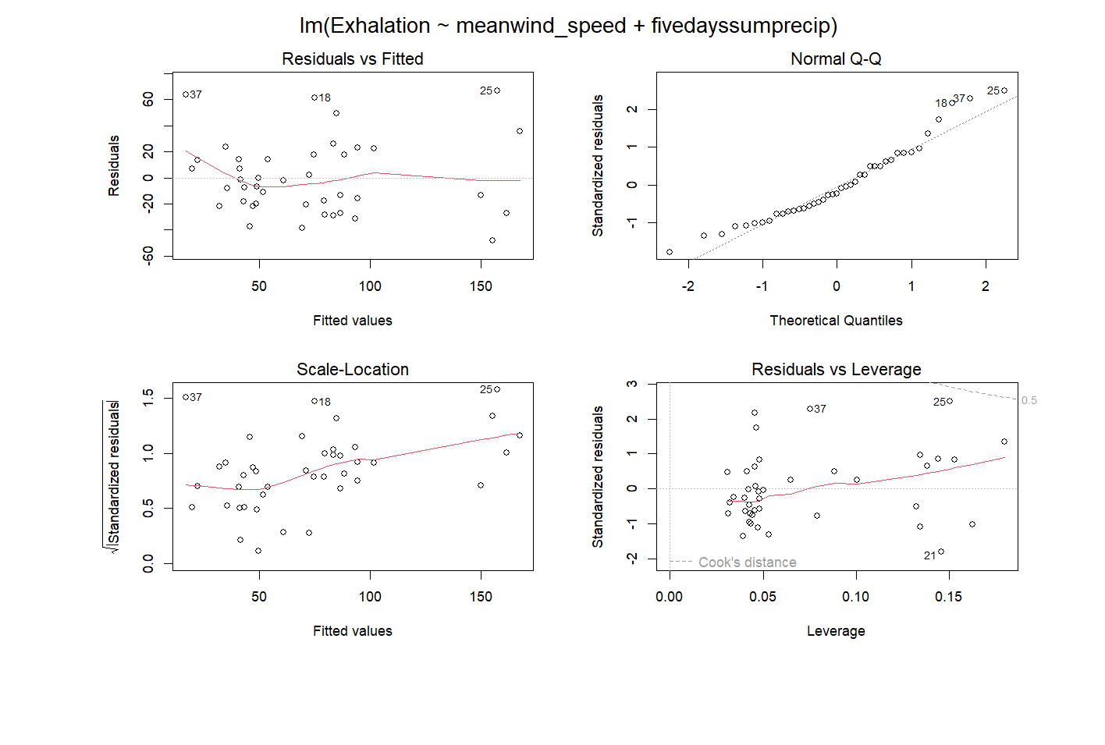

Mod 4 AIC=355 R2adj=0.72 F-stat: 17.82 on 5 and 28 DF, p-value: 6.142e-08

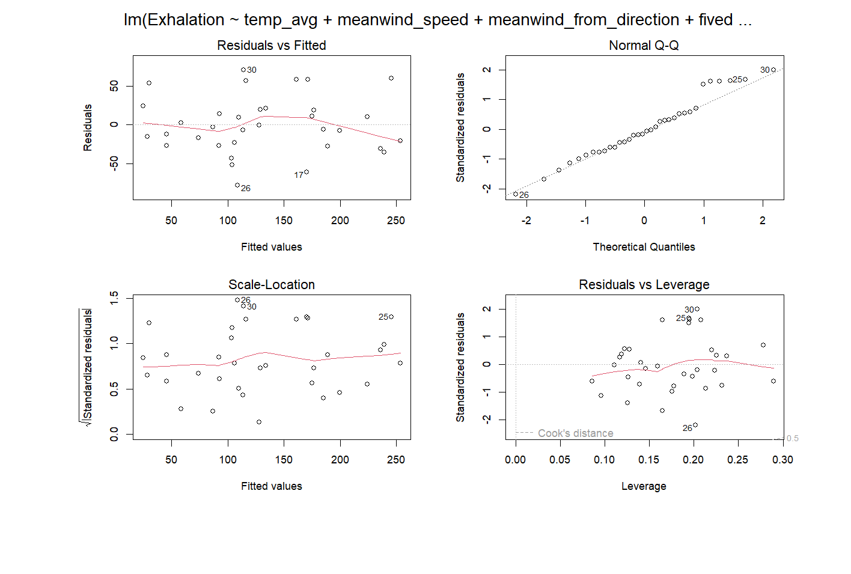

Mod5 AIC=331 R2adj=0.76 F-stat: 23.01 on 4 and 24 DF, p-value: 6.457e-08

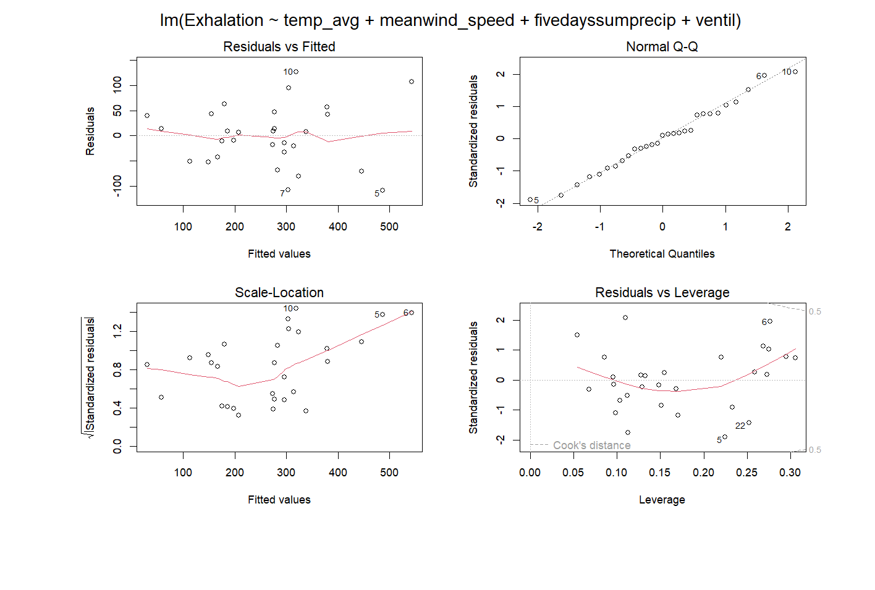
Mod6 AIC=436 R2adj=0.74 F-stat: 23.81 on 5 and 35 DF, p-value: 2.315e-10

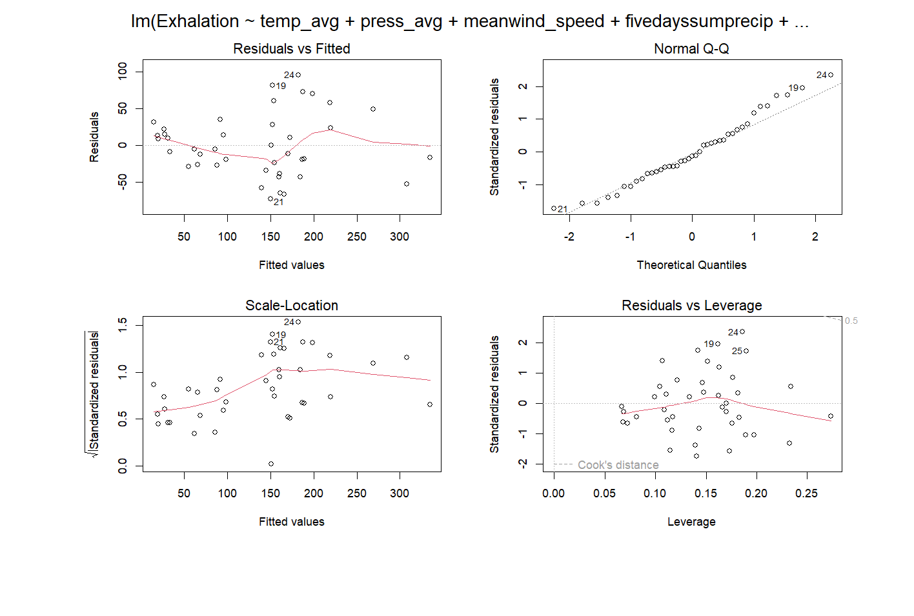
References:
Durridge Company Inc (2023) RAD7 Electronic Radon Detector User Manual, revision 2023-03-27 https://durridge.com/documentation/RAD7%20Manual.pdf.
Laraweb (2024) Laboratoire National Henri Becquerel" sitt "Library for gamma and alpha emissions.
Accessed 29 May 2024

