Supplementary Material

A- Overview of the project
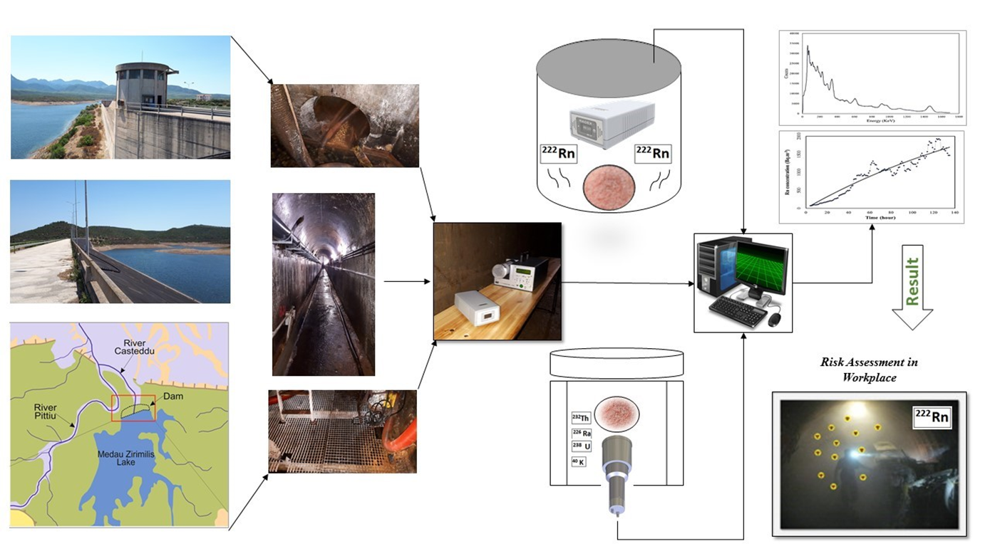
Figure S- 1: Graphical Abstract

B-Radon and gamma radiation setup

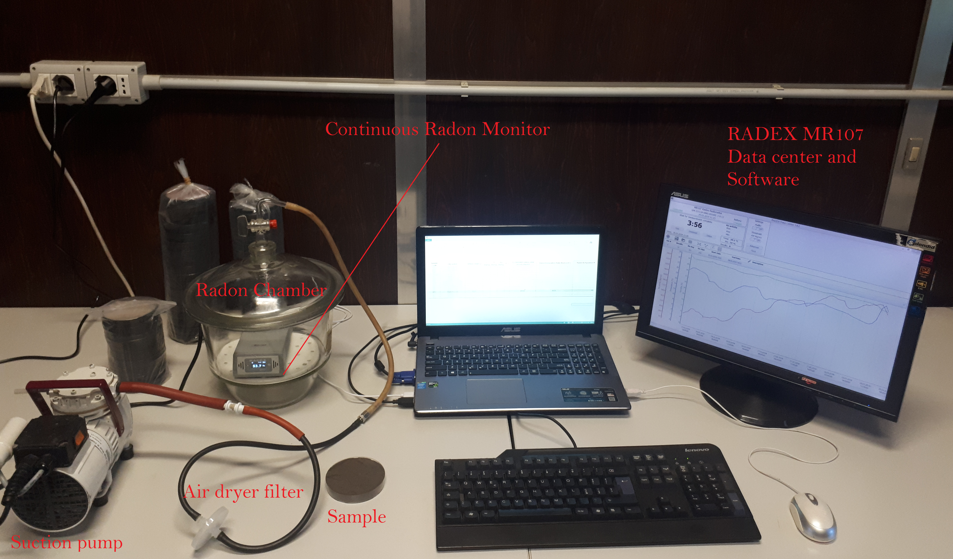
Figure S- 2: Setup for measurement of radon exhalation rate.

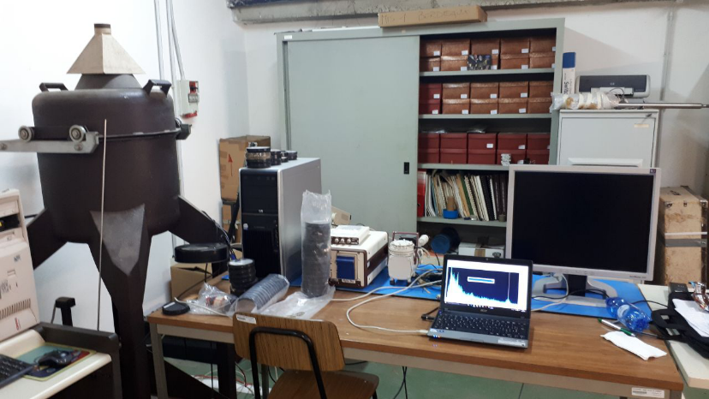
Figure S- 3: Ortec NaI (Tl) detector placed in the laboratory of nuclear physics - University of Cagliari.

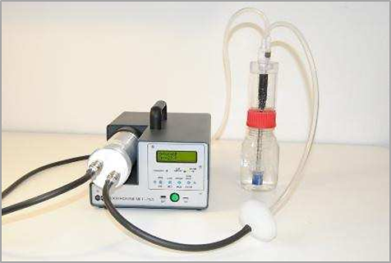
Figure S- 4: Setup for radon in water measurements. Photograph from manufacturer's website: https://www.miam.it

